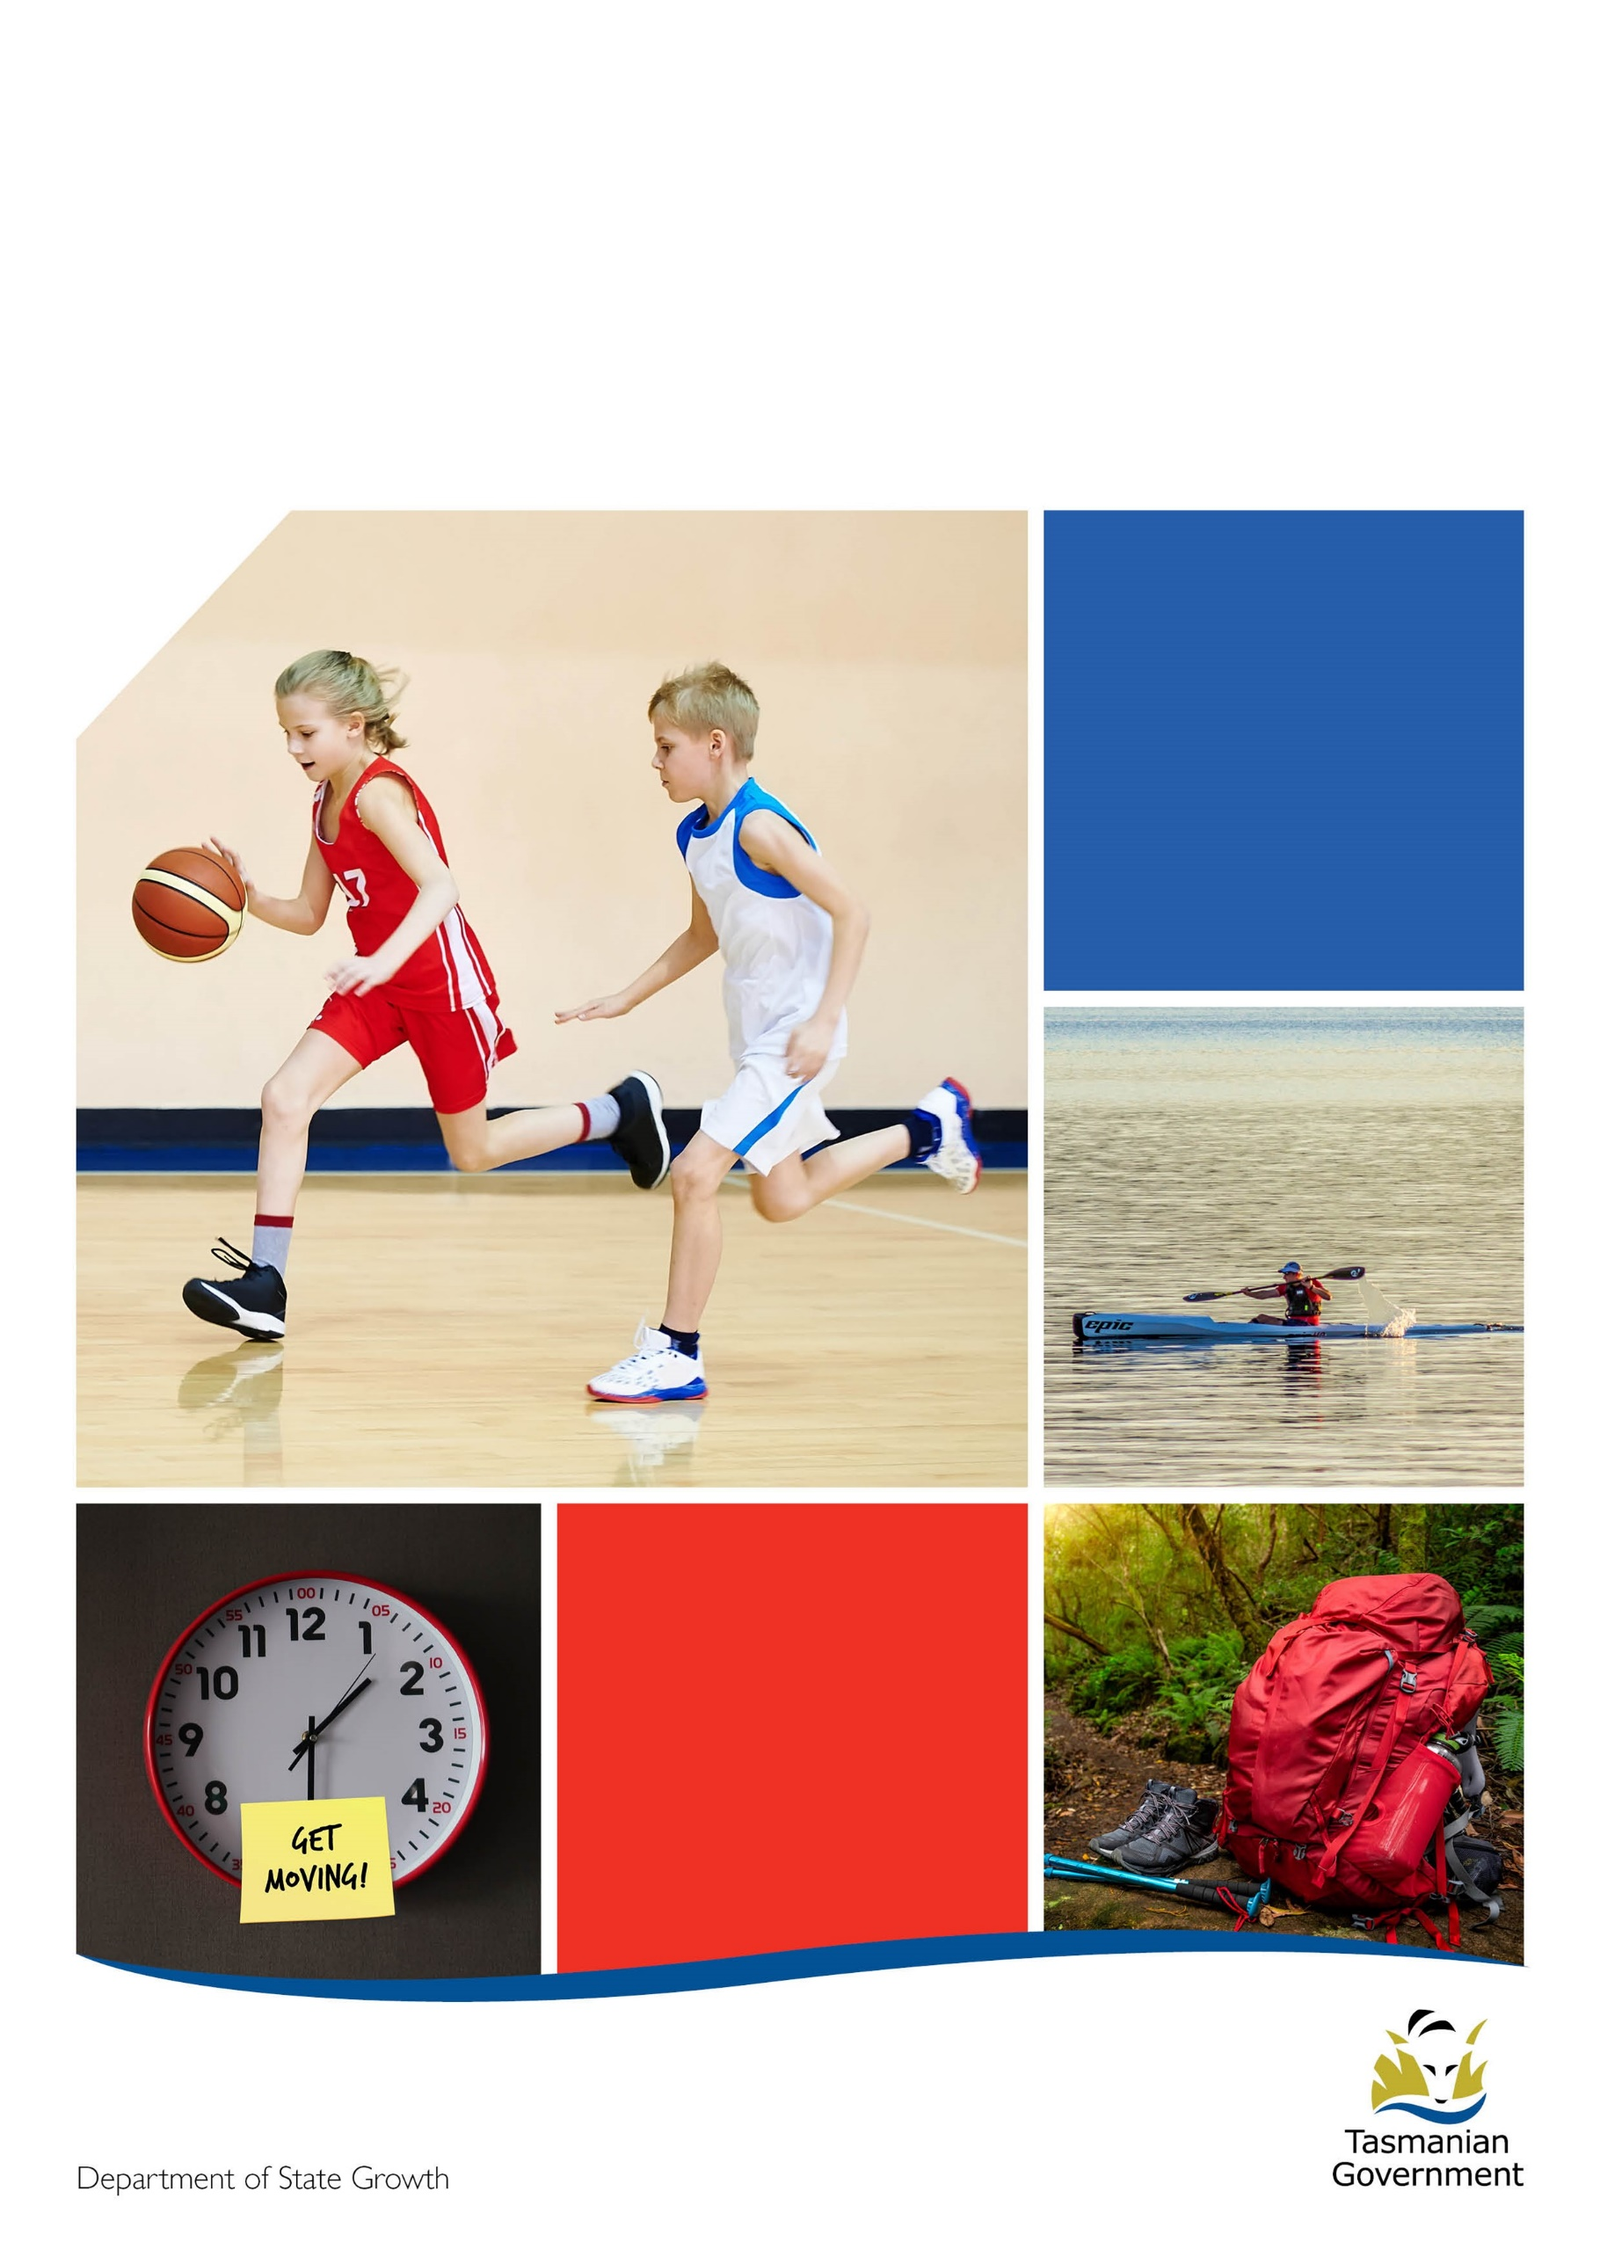
  - 2023-2024 Active Tasmania Equipment Grants Program

Guidelines
Contents
2023-24 Active Tasmania Equipment Grant Program 1
1. Eligibility criteria 1
1.1 Eligible applicants 1
1.2 Ineligible applicants 1
1.3 Eligible Equipment 2
1.4 Ineligible Equipment/expenses 2
2. Assessment criteria 2
3. Timeframes 3
4. Application process 3
5. Appealing a decision 3
6. Grant payments 3
7. Taxation and financial implications 4
8. Acquittal 4
8.1 How to acquit a grant 4
8.2 Failure to complete an acquittal 4
9. Administration and contact details 4
10. Publicity of grant assistance 4
11. Right to information 5
12. Confidentiality 5
13. Personal information protection 5
14. Disclosure 5
15. Disclaimer 5

2023-24 Active Tasmania Equipment Grant Program
The Tasmanian Government is committed to supporting all Tasmanians to access a range of high quality, safe, fair and inclusive sport and recreation opportunities.
The 2023-24 Active Tasmania Equipment Grants Program provides sport and active recreation organisations with grants of between $2,000 and $30,000 to assist with the purchase of additional or replacement equipment.
The Program is funded through the Community Support Fund (CSF). Legislation requires that funding under this Grants Program is provided for the benefit of sport and recreation clubs.
It is anticipated that approximately $1.27 million will be available for distribution under the 2023-24 Active Tasmania Equipment Grants Program.
Funding limits (per applicant) are:
Minimum funding amount: $2,000
Maximum funding amount: $30,000
Successful applicants must have a minimum of 30 per cent of the total funding requirements secured to contribute towards the project (see Secured Funds below).
Applicants must include a break-down of secured funding showing each funding source and provide evidence to demonstrate the funds are secured.
Secured funds must be evidenced by one or more of the following:
- Funds held in the organisation’s bank accounts and evidenced by a bank statement(s) clearly showing the name of the organisation and demonstrating financial capability to undertake the project
- Written confirmation of donation(s) of cash
- Written confirmation of sponsorship
- Written confirmation of funds secured from another grant provider (other contributions from the Tasmanian Government will not be considered as contributing to the 30 per cent); and/or
- Written confirmation of funds provided by a partner organisation.
This is a merit-based competitive grants program. Applicants will be assessed against the stated eligibility and assessment criteria.
The program is open until 2:00 pm, Friday, 8 March 2024. Late applications will not be accepted.
All applications will be acknowledged via an email receipt.
If no email receipt is received within 24 hours of lodgement, please contact Active Tasmania on 1800 252 476.
All applicants will be advised on the outcome of their application.

Eligibility criteria
For any queries about the eligibility criteria, contact Active Tasmania at grants@active.tas.gov.au or on 1800 252 476.
Applicants may be asked to supply documentation to support their eligibility claims as part of the application process, or as part of an audit process.

Eligible applicants
To be eligible for the grant, applicants must:
- be an organisation whose primary focus is to provide sport and active recreation activities to the Tasmanian community
and
- be an incorporated, not-for-profit organisation or
- a not-for-profit company registered under company law or
- a Local Government Association (LGA) providing equipment to benefit eligible sport and active recreation clubs

Ineligible applicants
Ineligible organisations include:
- State or Australian Government agencies.
- political organisations.
- individuals or sole traders.
- for profit organisations.
- educational institutions, including parents and friends’ associations.
- private or commercial enterprises registered under company law.
- organisations that receive revenue from electronic gaming machines.
- organisations that currently have a grant administered by Active Tasmania with overdue reporting and/or outstanding acquittal obligations.
- organisations that do not formally identify sport and/or active recreation as a primary purpose.
- organisations that have a focus on activities considered to be arts, hobbies, craft, music, historical re-enactments, events, pets or livestock related activities or that do not include the primary purpose of engaging in human physical activity.

Eligible Equipment
The 2023-24 Active Tasmania Equipment Grants Program supports the purchase of equipment that directly benefits a sport or recreation organisation and its members.
To be eligible, equipment must be one or more of the following:
- Essential playing and/or training equipment, and apparel. Where the purchase involves apparel, the applicant must demonstrate it has an asset register and that the apparel will remain the property of the organisation and not be provided to individuals.
- Safety equipment, such as first aid equipment, or goal post padding.
- Operational equipment, such as whitegoods, office equipment, IT hardware and software. Where the purchase includes computers, laptops, tablets, or other such equipment, the applicant must demonstrate it has an asset register, that users have signed an appropriate use of equipment agreement and that the equipment is only used for club related activities.

Ineligible Equipment/expenses
Any purchase made prior to submission of the Application Form is not eligible.
Ineligible items include (but are not limited to):
- the repayment of a loan or any other form of debt
- payment of wages or honorariums
- labour costs
- fixed infrastructure where statutory approvals from the land or site owner(s) are required, such as goals, timing devices and scoreboards
- recurrent operational costs, such as consumable items
- additional funds for a project already receiving funding support through an Active Tasmania grant program
- purchases that provide a direct economic benefit to an individual or business (projects must benefit a sport or active recreation club and its participants)
- purchases related to licenced areas, smoking areas, commercial areas or gaming areas
- personal issue laptops, tablets or computers.
- building materials or the upgrade/development of facilities.

Assessment criteria
Applications from eligible organisations for eligible equipment are assessed against the following criteria:
- demonstrated need/reason for equipment
- value for money
- Grant requested as a percentage of the project cost.
- Number of members/participants to benefit/grant amount requested for the project.
Priority may be given to equipment that:
- increases participation opportunities
- improves the quality or safety of participation
or
- improves the range of or access to participation opportunities.
This is a merit-based competitive grants program. Organisations that have membership restrictions may be considered a lower priority. In addition to the assessment criteria above, applications may be considered a lower priority if they:
- benefit a relatively small number of participants (other than those that target specific groups with specific needs)
or
- are submitted by organisations that have previously received Tasmanian Government funding for similar projects or where there appears to be a history that suggests an operational dependence on grants.
This grant program will be competitively assessed based on the quality of information provided by the applicant. Applicants should ensure all required and supporting information is lodged with the application.
Note - not all eligible grant applicants will receive funding.

Timeframes
Applications will not be accepted after the closing date.

Description | Date/time
Program opens | 8 January 2024  9:00 am
Program closes | Friday, 5 April 2024 2:00 pm
Applicants notified (estimated date) | June 2024
During the assessment process, Active Tasmania may at its discretion, contact applicants to confirm any changes or adjustments required, including removal of ineligible equipment items, income or expenditure amounts or GST calculation correction. Any requested information must be provided within five working days. Failure to provide further requested information within the timeframe is likely to result in the application being unsuccessful.

Application process
The Department of State Growth uses an online grants management system called SmartyGrants. This system is easy to use and accessible via mobile phones, tablets, laptops and personal computers.
Applicants without internet access should contact 1800 252 476 to discuss alternative methods to apply.
- Applicants should read the guidelines and any frequently asked questions (FAQs) carefully first. The application form is designed to help structure applicants’ responses to the eligibility and assessment criteria.
- This is a competitive, merit-based process. Meeting the eligibility criteria may not result in a successful grant.
- Applicants should ensure that all supporting documentation provided is accurate and is attached correctly before submitting.
- Applicants should complete and lodge an application online via SmartyGrants from the Active Tasmania website www.active.tas.gov.au
- Following the submission of the application via SmartyGrants, applicants will receive an automatic receipt of their application. This receipt will include details of the application and a unique application ID.
- Applications will be assessed by a Department assessment team and forwarded to a panel for final evaluation and a decision.
- Applicants will be advised of the outcome of their application.

Appealing a decision
The appeals process is designed to ensure that all applicants have been treated fairly and consistently in applying for Department of State Growth grants. The Department will consider appeals relating to administrative process issues in grants management.
All requests must be in writing and should be addressed to the Director Active Tasmania.
Your request must be received within 28 days of the date of the Department of State Growth notifying you of the decision about your application. For further information about the process, contact Active Tasmania on 1800 252 476.

Grant payments
Successful applicants will be asked for their bank account details to process grant payments. This bank account must be in the same name as the individual, business or organisation that applied for the grant. Applicants may be asked to provide a copy of their bank statement or a letter from their bank to confirm their bank account details.
Providing incorrect bank account details may result in funds being paid to an incorrect account. These funds will need to be returned to us before we attempt another grant payment. This process may result in significant delays in funding being received. Additionally, we cannot guarantee that funds paid to an incorrect bank account will be returned to us.
If a grant recipient:
- does not complete the activities or tasks required under the funding agreement,
- does not use any or all of the funding provided,
the recipient will be required to return some or all of the funds to the department.
Similarly, if
- the information provided to us is found to be false or misleading, or
- the recipient’s situation changes in a way that prevents completion of the agreed project
the recipient will be required to return some or all the funds to the department.

Taxation and financial implications
Grants distributed under the program attract GST. Grant payments to successful applicants, who are registered for GST, are increased to compensate for the GST payable. Where GST applies to the grant funding, a valid tax invoice must be supplied by the successful applicant to the department.
The receipt of funding from this program may be treated as income by the Australian Taxation Office (ATO).
It is strongly recommended that, prior to applying, potential applicants seek independent advice from a tax advisor, financial advisor and/or the ATO, about the possible tax implications for receiving the grant.
Information on invoices can be found on our Business Tasmania website www.business.tas.gov.au/manage_a_business/invoices

Acquittal
An acquittal is a statement made by a grant recipient, confirming that the grant funding was used as per the funding agreement. Unless otherwise stated, it is a requirement that all Department of State Growth grants are acquitted.

8.1 How to acquit a grant
An acquittal form will be provided to recipients, asking for information about the activities and expenditure relating to the grant. Evidence such as quotations, invoices, receipts, statements, reports, etc., are also required to support the acquittal.
The department may ask recipients to provide a Statement of Expenditure certified by an independent, professional auditor. In this situation the recipient will be responsible for the cost of obtaining the certified Statement of Expenditure.

8.2 Failure to complete an acquittal
Failure to lodge a valid acquittal by the due date will result in the recipient being required to return the funding to the department. In this situation the department will invoice the recipient.

Administration and contact details
The program will be administered by the Department of State Growth on behalf of the Crown in the Right of Tasmania. Contact Active Tasmania at grants@active.tas.gov.au or by phone on 1800 252 476.
All applicants must take care to provide true and accurate information. Any information that is found to be false or misleading may result in action being taken and grant funds, if already provided, will be required to be repaid to the department.

Publicity of grant assistance
The Department of State Growth disburses public funds and is therefore accountable for the distribution of those funds. As part of the accountability process, the department may publicise the level of financial assistance, the identity of the recipient, the purpose of the financial assistance, and any other details considered by the department to be appropriate.

Right to information
Information provided to the Department of State Growth may be subject to disclosure in accordance with the Right to Information Act 2009.

Confidentiality
The Tasmanian Government may use and disclose the information provided by applicants for the purposes of discharging its respective functions under the Program Guidelines and otherwise for the purposes of the program and related uses.
The department may also:
- Use information received in applications for any other departmental business.
- Use information received in applications and during the delivery of the project for reporting purposes.

Personal information protection
Personal information will be managed in accordance with the Personal Information Protection Act 2004.
This information may be accessed by the individual to whom it related, on request to the Department of State Growth. A fee for this service may be charged.

Disclosure
The following applies to all successful applicants:
- Despite any confidentiality or intellectual property right subsisting in the grant funding agreement or deed, a party may publish all or any part of the grant funding agreement or deed without reference to another party.
- Please note that all obligations under the Personal Information Protection Act 2004 (Tas) and the Privacy Act 1988 (Cwlth) still apply.

Disclaimer
Although care has been taken in the preparation of this document, no warranty, express or implied, is given by the Crown in Right of Tasmania, as to the accuracy or completeness of the information it contains.
The Crown in Right of Tasmania accepts no responsibility for any loss or damage that may arise from anything contained in or omitted from or that may arise from the use of this document, and any person relying on this document and the information it contains does so at their own risk absolutely.
The Crown in Right of Tasmania does not accept liability or responsibility for any loss incurred by an applicant that are in any way related to the program.

Department of State Growth

Active Tasmania
4 Salamanca Place
HOBART TAS 7000 Australia

Phone: 1800 252 476
Email: grants@active.tas.gov.au
Web: www.active.tas.gov.au

